**Single sign-on (SSO) for EYE+ Salesbuddy (Only for ABM’s & RBM’s)**

The Single Sign-On process that enables enhance and better login experience to the ABM’s & RBM’s to access Salesbuddy.

**For web:**

**Step1:** Goto the SalesBuddy website <https://salesbuddy.titan.in/eyecare/login>

**Step 2**: Select your respective persona **ABM** or **RBM** and click on Next Button.

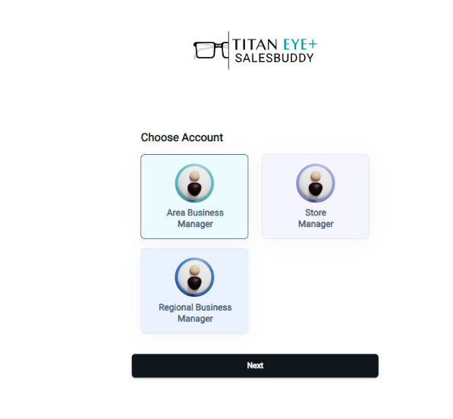

Select your persona

**Step3:** You will be automatically redirected to the landing page without entering the user ID & password.

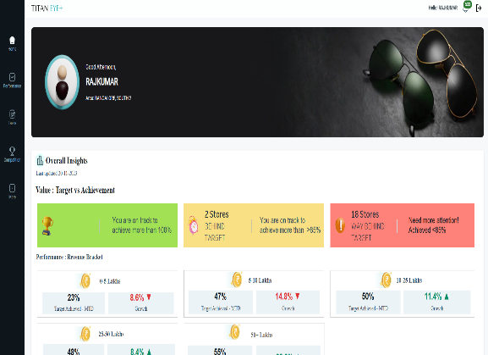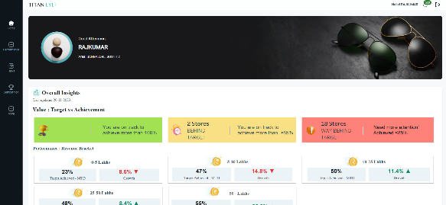



Note: 1) Data represented in the document is dummy data.

2) Not Applicable for SM Process.